Picaxe to Raspberry Pi serial Interface
This document describes the protocols used in serial data transmission between a picaxe radio receiver node, and a raspberry pi node. Together, the make the collector system.
The setup should look like this:
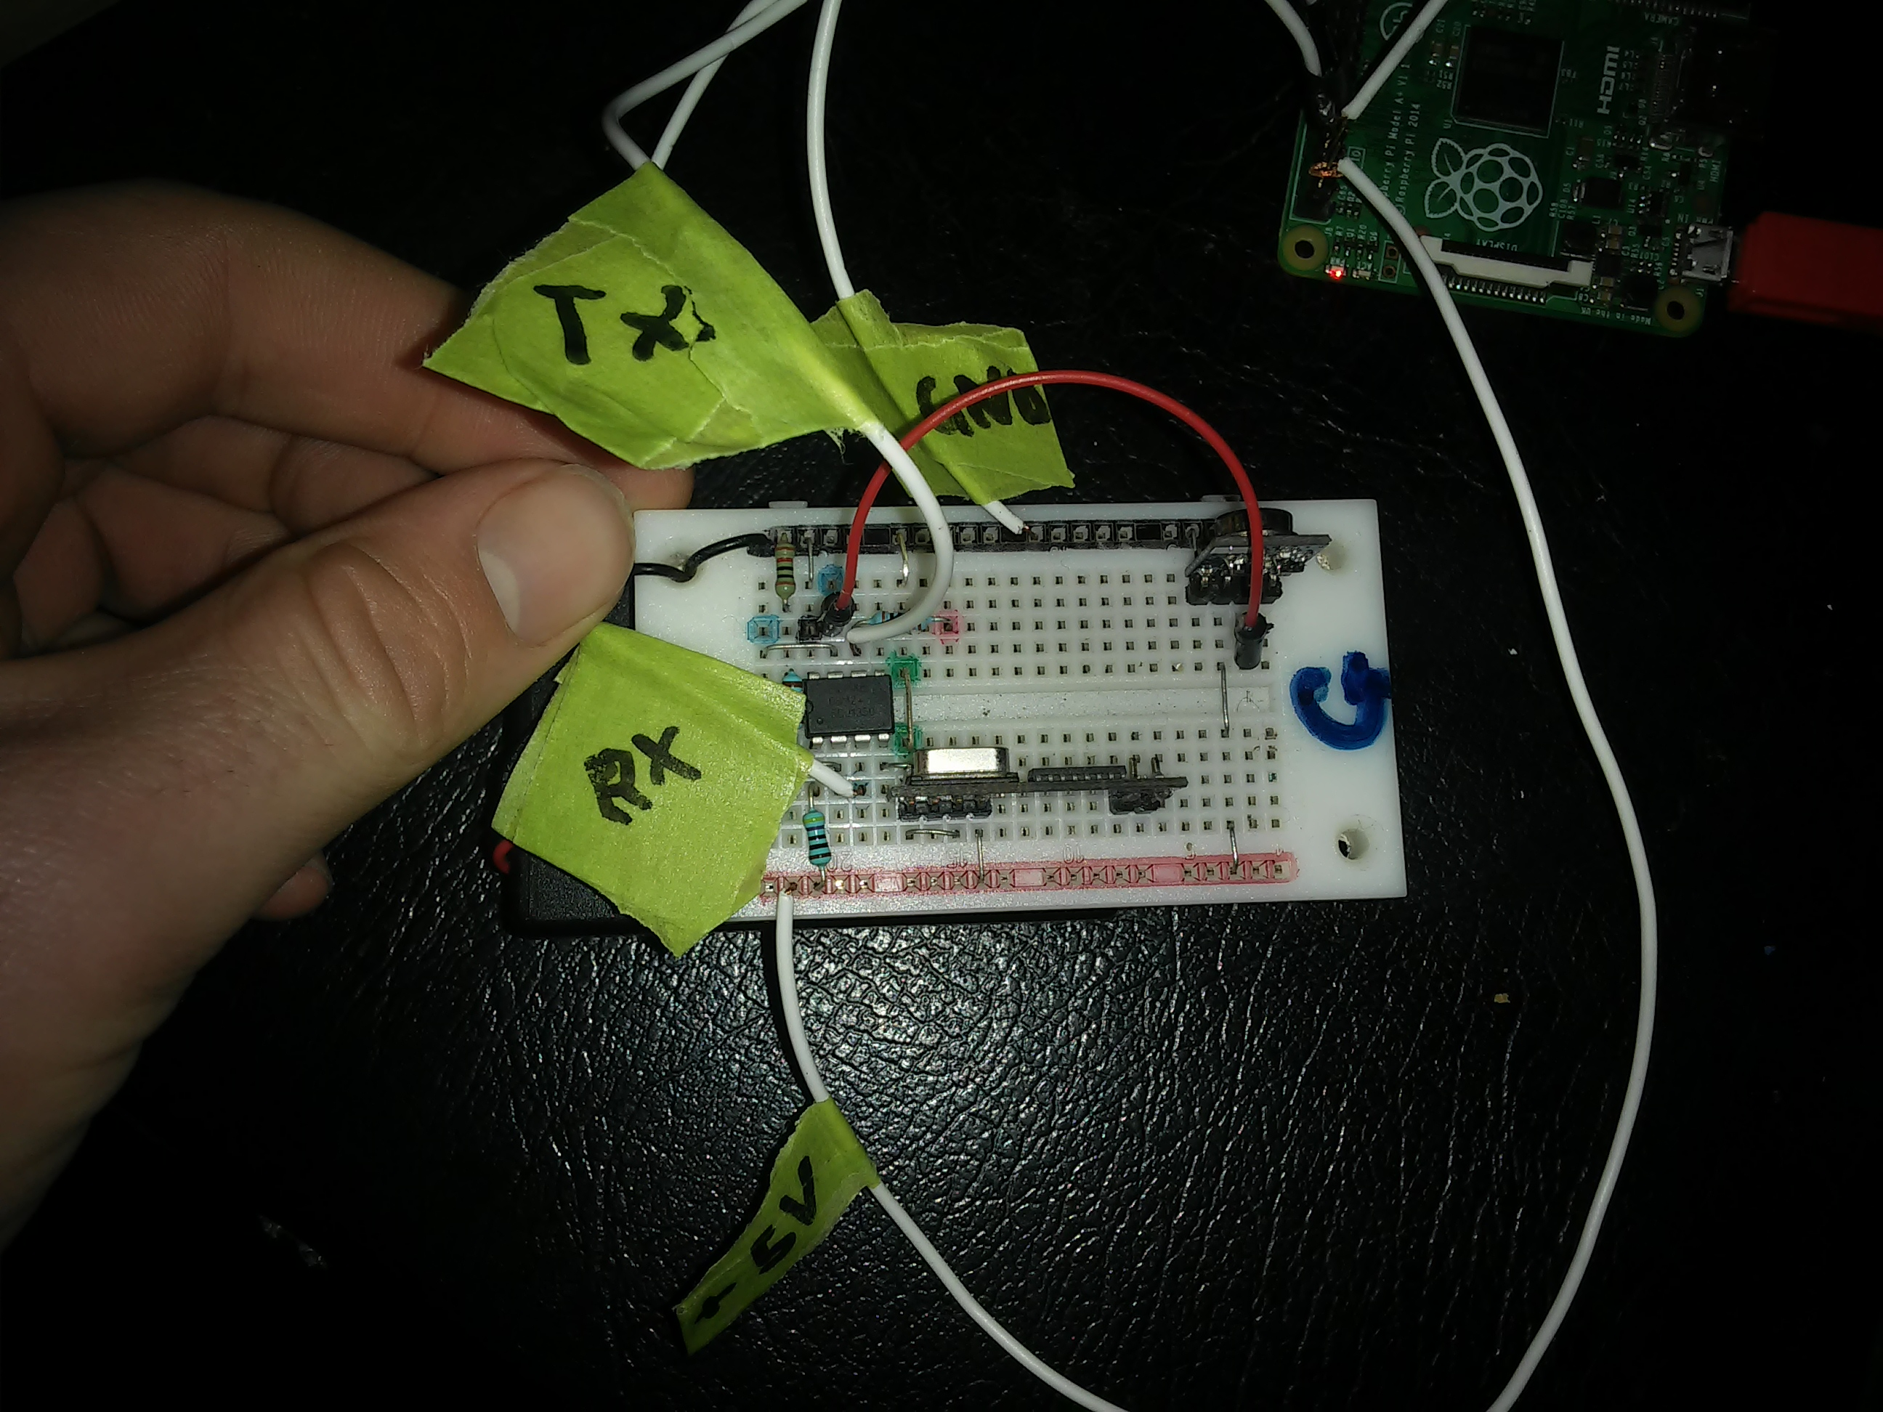
With Labels referring to the GPIO pins on the raspberry pi, 5V to the 5v power rail, TX to the serial transmit pin, GND to ground, etc.
Baud rate is 2400
port is /dev/ttyAMA0, this may change in differing pi versions, and can be changed in the port variable, as the port variable in python script serialinterface.py
The python module provided is serialinterface.py, this should be imported to any script made to handle picaxe data.
The serialinterface.py script also requires the file '.receiverpass' This should contain 2 numbers, less than 100, on sepperate lines, it may also have a comment denoted by a hash (#)

To read serial data using serialinterface.py, simplely create a connection object, the use the get_input function.
Import serialinterface
Conn = serialinterface.Connection()
print conn.get_input()

This will altomatically handle everything, the following show behind the scenes.
When the picaxe is first power, it will consantly send the message “SetRe” over serial. This is short for “Setup Request” When you call get_input(), it will first check for a setup request, and if so responed by send “Conf:<passcode1><passcode2>” where the passcodes are read in from .receiverpass. The picaxe uses these values to verify that the data is legitimate.
After this setup stage, the picaxe will check all data it receivers over the air, send acklodgement signles back, and forward all verified signles to the raspberry pi over serial. The get_input function reads the serial input, reculates the checksum for further verification, then converts the data to an int and returns it to whatever called the function.

